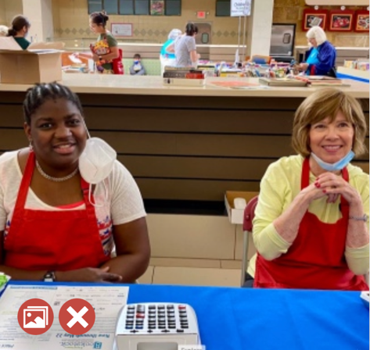

Join the Oakland Literacy Council team!

Volunteer at Bookstock 2023 OLC Days!

Fri., April 28, 2023 (PM) and Sat., April 29, 2023

Laurel Park Place, Livonia
When you volunteer at Bookstock, you are directly raising money so Oakland Literacy Council can keep providing FREE tutoring for adults. It is a fun way to make a difference!
Click below to sign up for a shift.

<ENTER YOUR SIGNUP GENIUS LINK>

- Volunteers will serve as cashiers, greeters, salespersons, and more.
- No experience necessary. Training will be provided.
- Invite your friends, family, coworkers, book clubs, etc. to volunteer, too (Age 16+)!
- Detailed location/parking information will be provided closer to the sale date.
- Learn more about the sale at www.bookstockmi/sale-info.
NOTE: Once you register, you will receive a confirmation e-mail from Signup Genius with a volunteer manual and information about upcoming virtual volunteer training sessions.
Thank you and please join me – it’s a fun to make a difference in our community!
Sue
Sue Klunk
OLC Bookstock Day Chair
sue.k@oaklandliteracy.com
248.884.4461

